# NETWORKING & SYSTEM ADMINISTRATION LAB

**Name: Stebin Babu**

**Roll No: 44**

**Batch: B**

**Date: 31/03/2022**

**Experiment No.: 3**

# Aim

Familiarization of the linux commands.

# Procedure

1. **cut -d**

This command is used to cut and display the content based on the delimiter given. Syntax :- $ cut –d delimiter –fieldnumber filename

Output :-

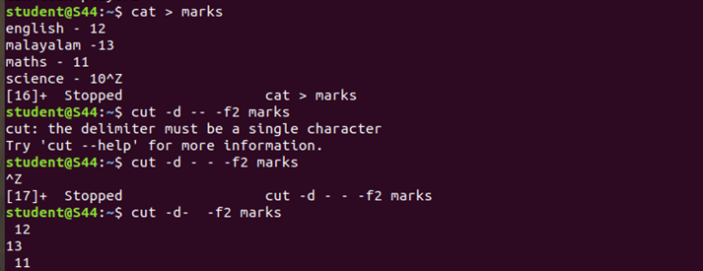

# cut -b

This command is used to cut and display the content based on the specified byte number.

Syntax :- $ cut –b bytenumber filename Output :-

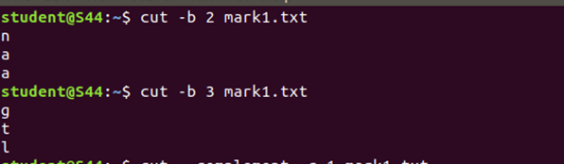

# cut --complement -c

This command is used to erase the specified character and display the remaining content of the file.

Syntax :- $ cut --complement –c characternumber filename.txt Output :-

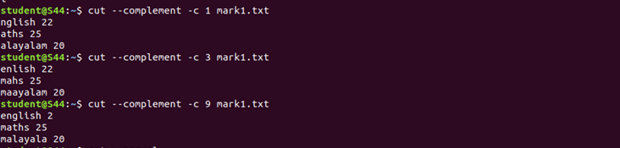

# paste

This command is used to paste the contents from the specified file. Syntax :- $ paste filename

Output :-



# paste file1 file2 > file3

This command is used to paste the contents from the specified files to another file. Syntax :- $ paste file1 file2 > file3

Output:-

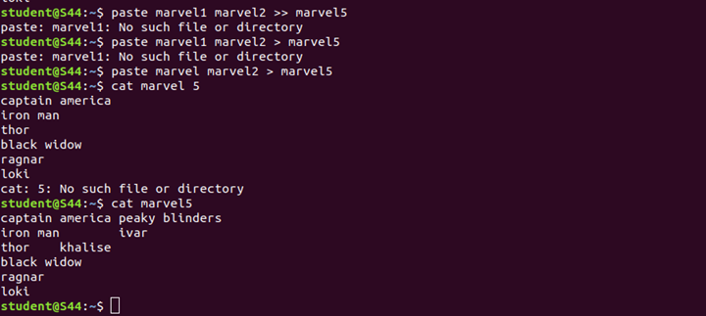

# paste -s

This command is used to paste the contents sequentially. It reads all the lines from the file and merges all these lines into a single line with each line separated by tab.

Syntax :- paste –s file1 file2 Output :-



# paste -d

This command is used to paste the contents from the given files with the delimiter

given.

Syntax :- $ paste –d delimiter file1 file2 Output :-

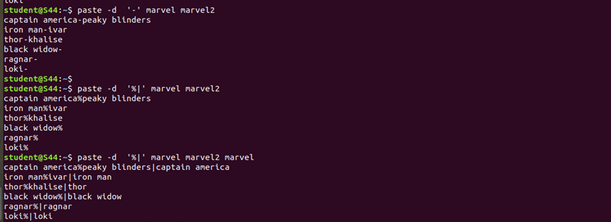

# more

This command is used to view the text files in the command prompt, displaying one screen at a time in case the file is large.

Syntax :- $ more filename Output :-

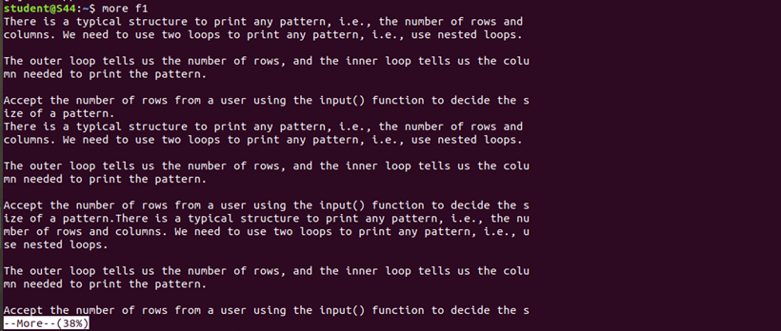

# more -number

This command is used to display display the lines to the specified number from

head

Syntax :- $ more -number

Output :-

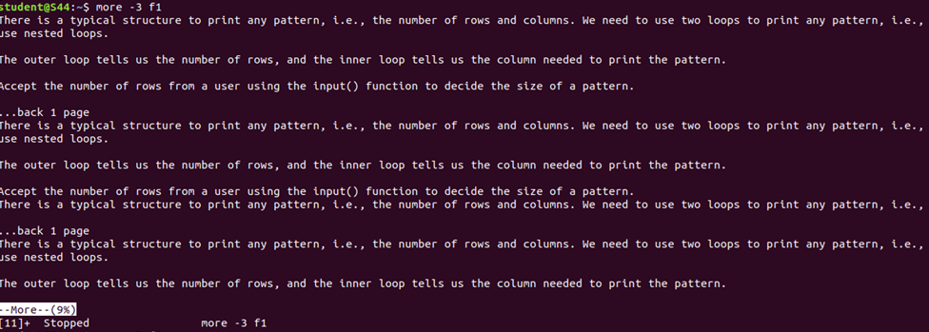

# more +number

This command use the line number from where we want to displaying the text content.

Syntax :- $ more +number Output :-

